ABDUL RAHMAN AL-SUMAIT UNIVERSITY


DEPARTMENT OF MATHS AND COMPUTER SCIENCE COURSE

NAME: CLOUD COMPUTING COURSE CODE: BIT 354
LECTURER NAME: MR. ABDULHAMID AHMED
ASSGNMENT TYPE: INDIVIDUAL ASSIGNMENT
YEAR OF STUDY: 3rd YEAR, 1st SEMESTER, 2025/2026.
NAME: ISMAIL MOHAMMED VUAI
REG NO: 23/ICT/001

ACKNOWLEDGEMENT
I would like to extend my sincere gratitude to my lecturer, Mr. Abdulhamid Ahmed, for his professional guidance, insightful lectures, and for assigning this practical task. This assignment has been instrumental in deepening my technical understanding of cloud storage dynamics, file management, and collaborative digital environments.
Special thanks also go to Sumait University for providing the necessary academic resources and the IFNOSS platform, which facilitates a seamless learning and submission process.
Furthermore, I appreciate the support of my peers for their collaborative spirit during our discussions on various cloud computing concepts. Finally, I am grateful for the opportunity to develop practical skills that are essential for my future career in the ICT industry.

TABLE OF CONTENTS
ACKNOWLEDGMENT......................................................................................... 1
1.0 INTRODUCTION ........................................................................................... 1
2.0 PART A: FILE MANAGEMENT................................................................. 2
2.1 Task 1: Upload and Organize Files ................................................................ 2
2.2 Task 2: Subfolder Creation and File Migration ............................................. 3
3.0 PART B: COLLABORATION AND ACCESS CONTROL....................... 4
3.1 Task 3: Sharing Folder with User Permissions .............................................. 4
3.2 Task 4: Monitoring Activity and Managing Permissions ............................... 5
4.0 PART C: ADVANCED FEATURES ............................................................. 6
4.1 Task 5: Version History and Document Restoration ..................................... 6
4.2 Task 6: Link Sharing and Incognito Verification .......................................... 7
5.0 PART D: TECHNICAL ANALYSIS ............................................................ 8
5.1 Benefits of Organizing Files in the Cloud..................................................... 8
5.2 Importance of Access Control in Collaboration............................................ 9
5.3 The Role of Version History in Data Integrity............................................... 9
6.0 CONCLUSION AND RECOMMENDATIONS .......................................... 10
7.0 REFERENCES............................................................................................... 11

1.0 Introduction
"This report outlines a practical exploration of cloud storage management and collaborative workflows using Google Drive. In the modern digital landscape, cloud computing serves as a backbone for data accessibility and team synergy. The primary focus of this assignment is to demonstrate proficiency in systematic file organization, the implementation of robust access controls, and the utilization of advanced features like versioning to ensure data integrity and seamless cooperation in a cloud-based environment."
2.0 PART A: FILE MANAGEMENT
2.1 Task 1: Upload and Organize Files
The initial phase of this task involved setting up a centralized storage structure within the Google Drive environment.
- Folder Creation: A primary directory titled "Cloud Computing Assignment" was created to house all relevant academic materials.
- File Migration: To simulate a real-world working environment, four distinct file types were prepared and successfully uploaded into the primary folder:
  - Assignment.pdf (Portable Document Format for fixed layouts)
  - Report.docx (Word processing document for textual data)
  - Presentation.pptx (Slide deck for visual representation)
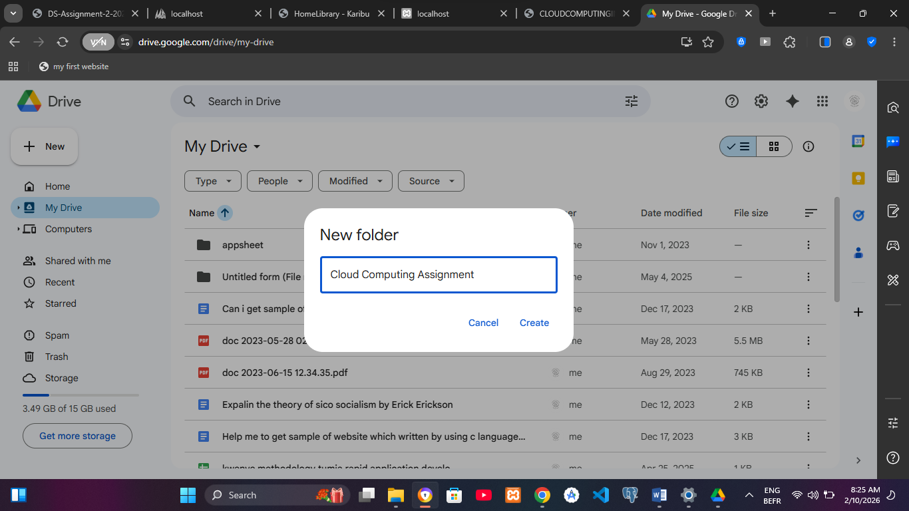
  - Diagram.png (Image file for graphical data)
Screenshot 1: Showing the "Cloud Computing Assignment" folder with the four files inside

2.2 Task 2: Organizing Files into Subfolders
To enhance file discoverability and maintain a clean cloud architecture, subdirectories were created within the main folder:
- Subfolder Creation: Three subfolders were generated: "Reports", "Presentations", and "Images".
- File Sorting: Files were moved to their respective locations to ensure logical organization:
  - Report.docx moved to Reports.
  - Presentation.pptx moved to Presentations.
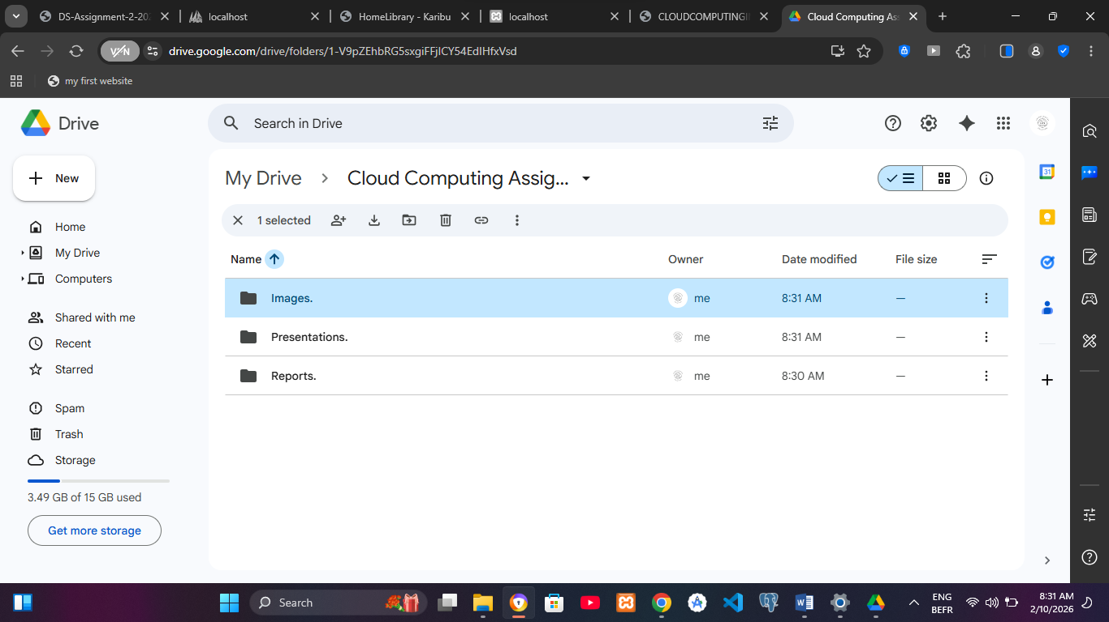
  - Diagram.png moved to Images.

Screenshot 2: Showing the subfolders and the organized structure
- File Sorting: Files were organized and moved into their appropriate categories:
  - Report.docx was migrated to the "Reports" subfolder.
  - Presentation.pptx was migrated to the "Presentations" subfolder.
  - Diagram.png was migrated to the "Images" subfolder.

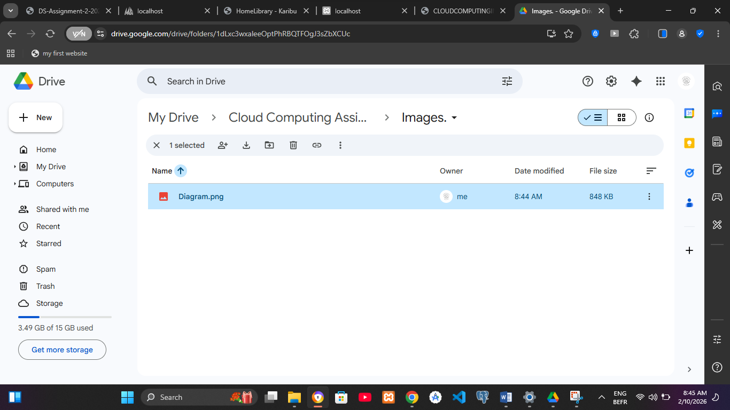
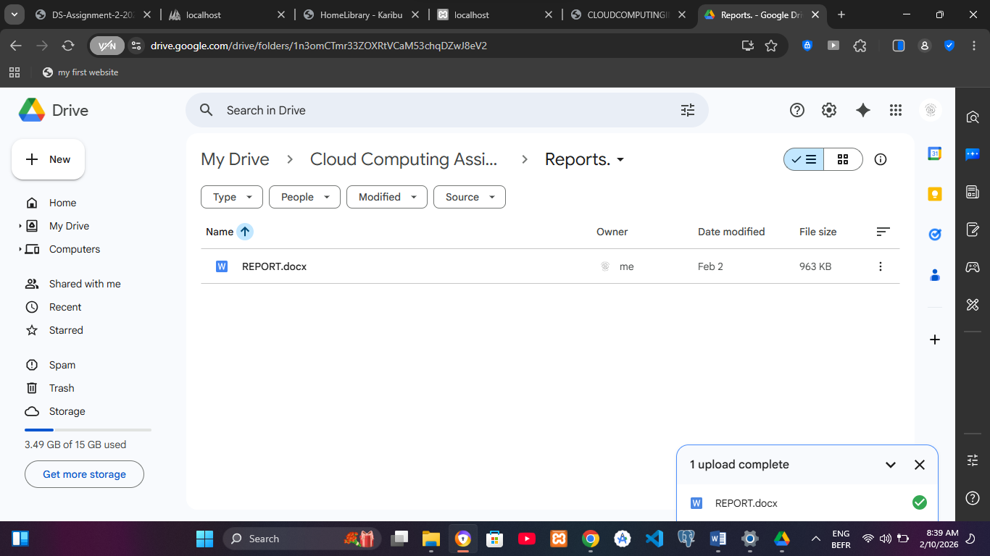
Screenshot 3, for report document
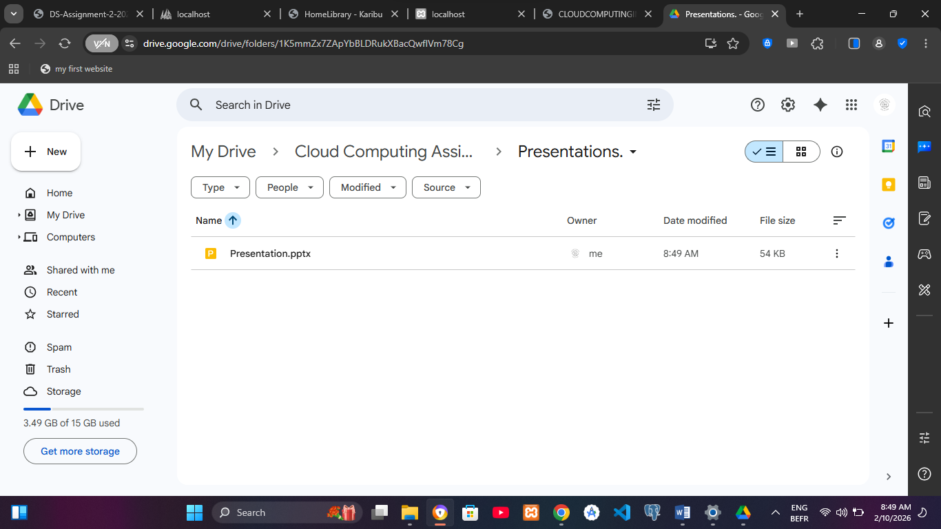
Screenshot 4 for image diagram file
Screenshot 5, FOR PPT FILE
Screenshot 3, 4, 5: Showing the expanded folder view or the inside of one of the subfolders to verify the move

3.0 PART B: COLLABORATION AND ACCESS CONTROL

3.1 Task 3: Sharing Folder with User Permissions
In this task, collaborative access was established for the "Cloud Computing Assignment" folder. This process demonstrates the ability to manage multi-user environments in the cloud.
Steps Taken:
- Selection: Right-clicked on the "Cloud Computing Assignment" folder and selected the Share option.
- Assigning Student 1: Entered the email address othmanali7299@gmail.com and set the permission level to Viewer. This ensures they can see but not modify the content.
- Assigning Student 2: Entered the email address Kazijakassim17@gmail.com and set the permission level to Editor, granting them full rights to modify files.
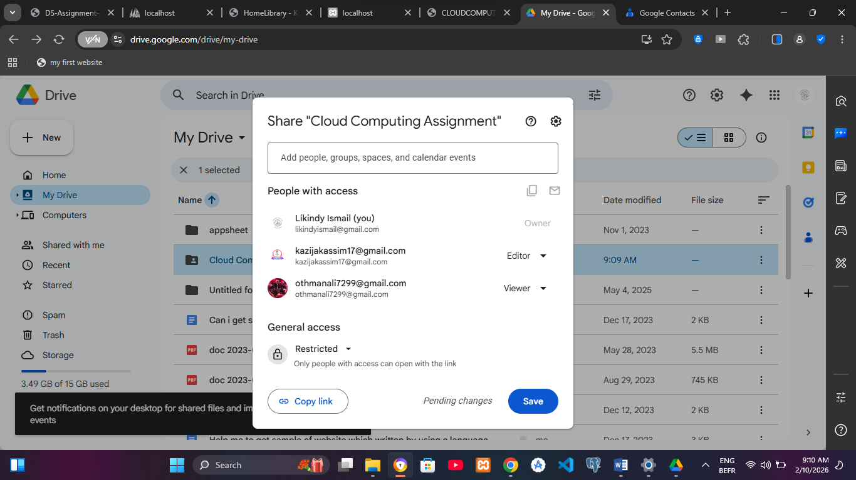
- Notification: Unchecked the "Notify people" box (optional) and clicked Share.

Screenshot 6: Showing the 'Share with people' dialog box with both emails and their respective Viewer/Editor roles

3.2 Task 4: Monitoring Activity and Managing Permissions
Cloud administration requires active monitoring and periodic adjustments of access rights to maintain security.
Steps Taken:
- Activity Audit: Opened the "Details" pane (Info icon) in Google Drive and selected the Activity tab to verify recent changes made by collaborators.
- Permission Update: Re-opened the Share settings.
- Modification: Changed Student 2 from an "Editor" to a Viewer to restrict their writing privileges.
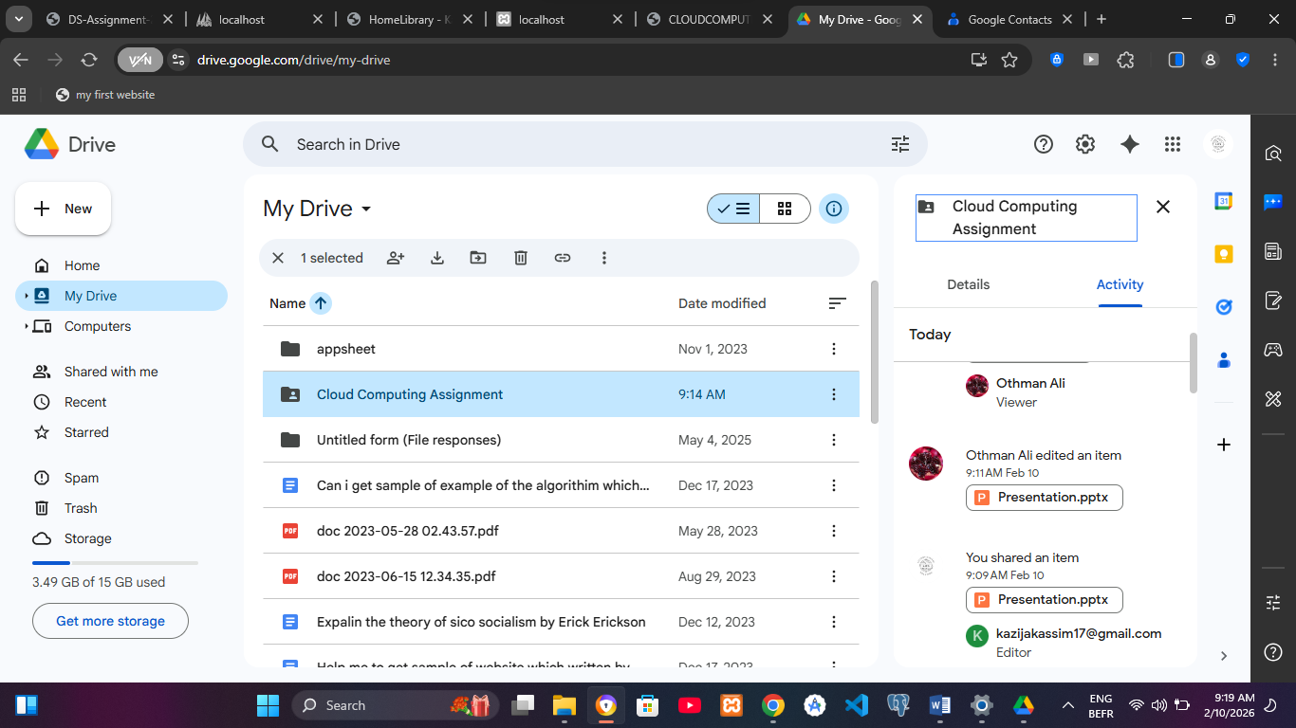
- Revocation: Selected Student 1 and clicked "Remove access" to completely withdraw their permission to view the folder.
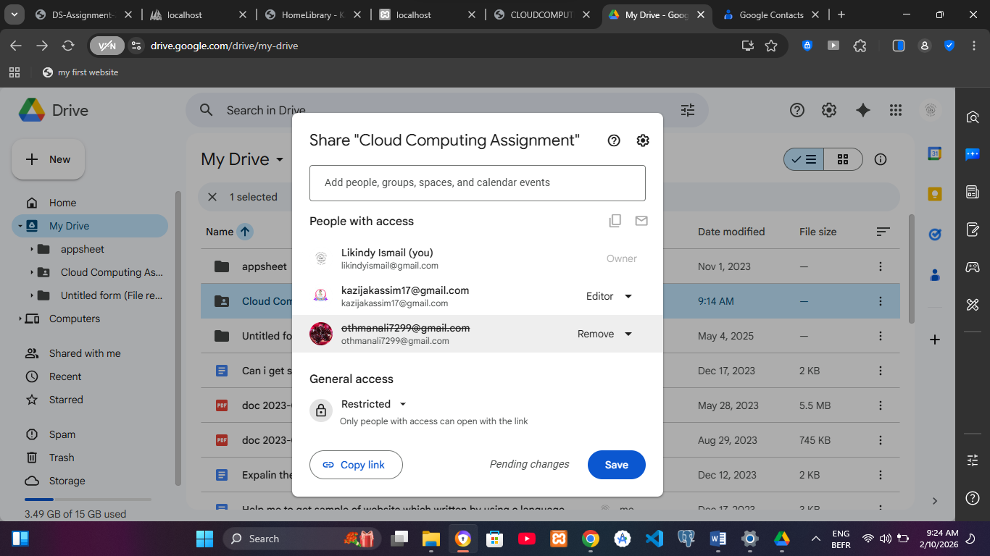
Screenshot7& 8: Showing the updated permission list or the Activity Log showing these changes

4.0 PART C: ADVANCED FEATURES

4.1 Task 5: Version History and Document Restoration
This task demonstrates "Point-in-Time Recovery," a crucial feature for protecting data against accidental errors.
Steps Taken:
- Editing: Opened Report.docx via Google Docs and added a new section titled "Preliminary Findings."
- Accessing History: Navigated to File > Version history > See version history.
- Comparison: Viewed the timestamped list of changes on the right-hand panel.
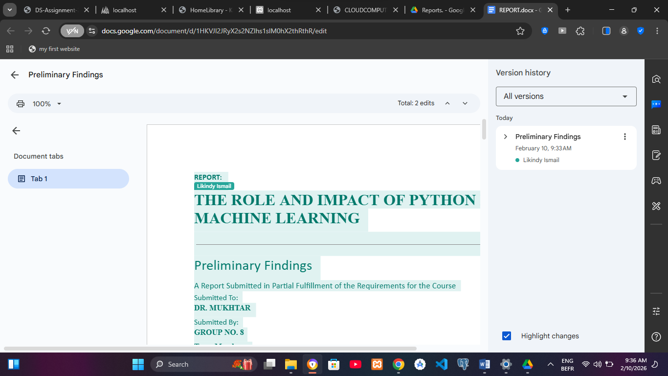
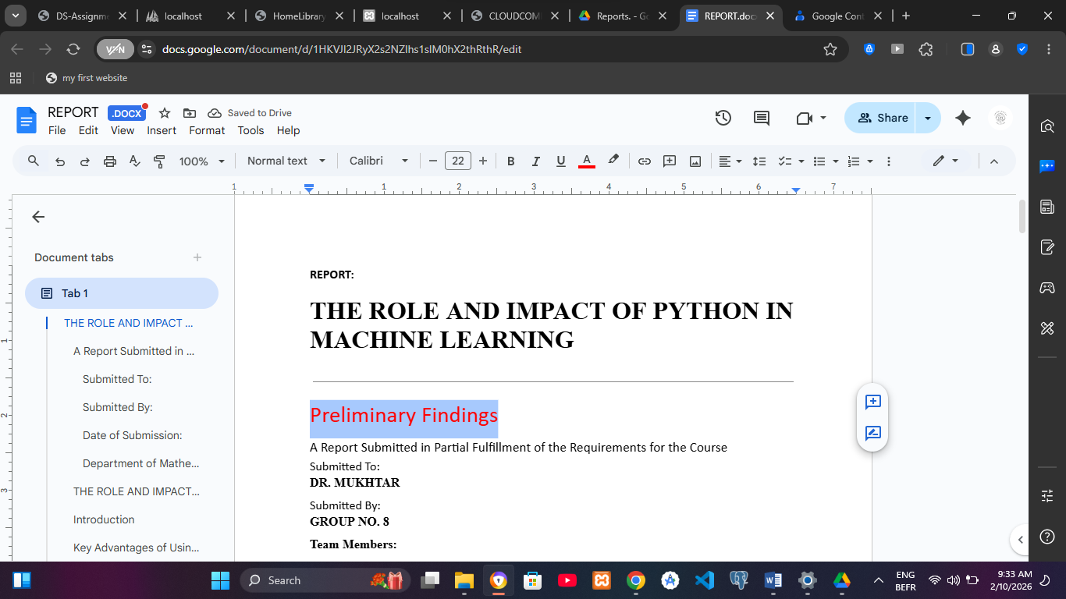
- Restoration: Selected the original version (the blank or initial state) and clicked Restore this version.
Screenshot 9 & 10: Showing the Version History panel on the right side of the screen
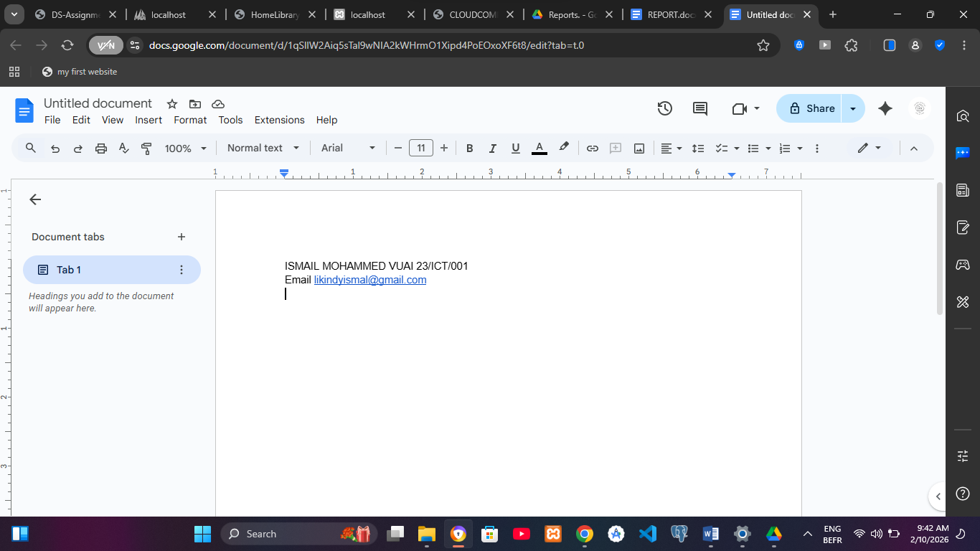
Screenshot 11: Showing the original version was restored, ensuring no unintended changes remained.

4.2 Task 6: Link Sharing and Incognito Verification
Link sharing is used for broad distribution without requiring specific email invites.
Steps Taken:
- Link Generation: Right-clicked the "Presentations" subfolder and selected Get link.
- Setting Restrictions: Changed the General Access from "Restricted" to "Anyone with the link" and set the role to Viewer.
- Verification: Copied the link and opened a New Incognito Window in the browser.
- Test: Pasted the link to confirm that the folder is accessible without being logged into a Google account.

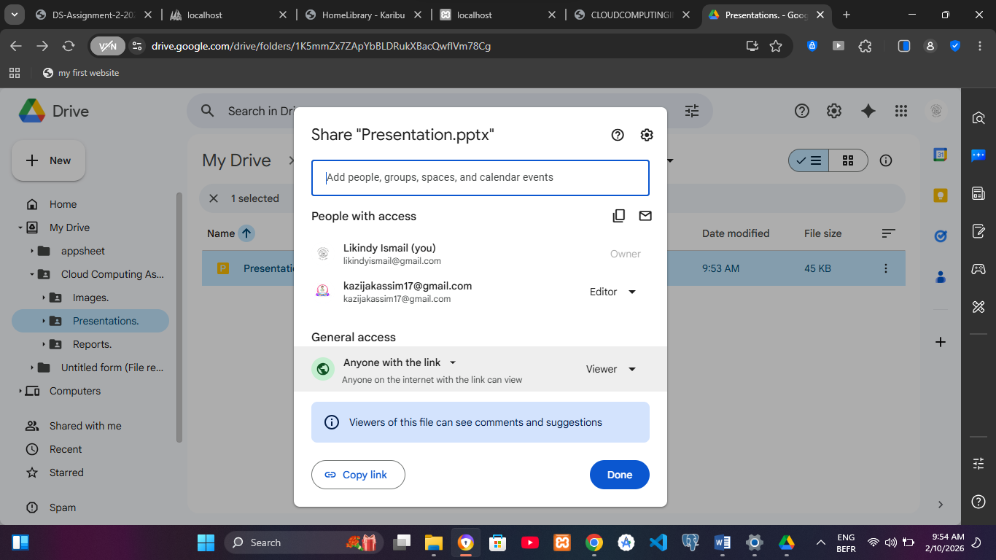
A shareable link for the "Presentations" subfolder was generated. The link permissions were set to "Anyone with the link can view."
Screenshot 12: Showing the Incognito browser window successfully displaying the Presentations folder

5.0 PART D: TECHNICAL ANALYSIS

5.1 Benefits of Organizing Files in the Cloud
Organization in a cloud environment is more than just "tidiness"—it is about efficiency.
- Search ability: Categorizing files into subfolders reduces the time spent searching for data, especially as storage volume grows.
- Scalability: A systematic structure allows for more files and users to be added to the project without creating confusion.
- Metadata and Indexing: Google Drive uses the folder structure to help index items, making it easier for the search algorithm to locate relevant documents quickly.

5.2 Importance of Access Control in Collaboration
Access control is vital for maintaining the security and integrity of shared data.
- Data Security: By assigning "Viewer" status instead of "Editor," we prevent unauthorized or accidental deletion of sensitive files.
- Accountability: Knowing who has access to which folder allows administrators to monitor activity logs and see who made specific changes.
- Principle of Least Privilege: This ensures that collaborators only have the permissions necessary to complete their specific tasks, reducing the risk of data breaches.

5.3 The Role of Version History in Data Integrity
Version history acts as a "Time Machine" for digital documents.
- Error Recovery: If a collaborator accidentally deletes a paragraph or makes an incorrect edit, version history allows for an immediate "Rollback" to a previous state.
- Audit Trail: It provides a transparent record of how a document has evolved over time, showing exactly what was changed and by whom.
- Conflict Resolution: In real-time collaboration, if two people edit the same line, version history helps identify and restore the correct intended data.

6.0 CONCLUSION AND RECOMMENDATIONS

Conclusion
This assignment successfully demonstrated the practical application of cloud storage management using Google Drive. Through the systematic organization of files, the implementation of tiered access controls, and the utilization of recovery features like version history, I have gained a comprehensive understanding of how cloud environments facilitate secure and efficient collaboration.
The transition from traditional local storage to cloud-based solutions is essential for modern organizations. This practical exercise highlighted that the cloud is not merely a "hard drive in the sky," but a sophisticated ecosystem that ensures data integrity, availability, and security across geographical boundaries. All tasks were completed as required, confirming that Google Drive is a robust tool for academic and professional document management.

Recommendations
Based on the practical tasks performed, the following improvements are recommended for better cloud management:
- Enable Two-Factor Authentication (2FA): To further protect shared folders, all collaborators should be required to use 2FA to prevent unauthorized access.
- Periodic Access Audits: Organizations should conduct monthly reviews of "Link Sharing" and user permissions to ensure that former members or unnecessary links do not maintain access to sensitive data.
- Use of Shared Drives: For larger team projects, using Google "Shared Drives" (rather than a personal drive) is recommended so that the organization, not an individual, owns the files.

7.0 REFERENCES
- Sumait University. (2026). BIT 354 - Cloud Computing Course Material: Unit 10 - Cloud Storage. ---

